A step by step guide for Quality Counts
(Please read every step very CAREFULLY)
- Go to this website: https://www.texaslivestockvalidation.com/qc/qcregister.aspx
- Fill in the following information under Exhibitor Information. You should fill out
  - Given First Name
  - Preferred Name: (THIS SECTION IS OPTIONAL)
  - Your Last Name:
  - Your Phone Number:
  - Your Email Address: (DO NOT USE YOUR SCHOOL EMAIL)
- Next you will go to the section that has you select your 4H and FFA affiliation.
  - For the 4H Affiliation section DO NOT CLICK ANYTHING!! LEAVE IT AT -SELECT ONE-
  - For FFA Affiliation section, scroll through and select the high school that you are currently at. It will be one of the following options:
    - Bridgeland
    - Cy-Fair FFA
    - Cypress Creek FFA
    - Cypress Falls FFA
    - Cypress Lakes FFA
    - Cypress Park FFA
    - Cypress Ranch FFA
    - Cypress Ridge FFA
    - Cypress Springs FFA
    - Cypress Woods FFA
    - Jersey Village FFA
    - Langham Creek FFA
- Next enter your birthday in the date of birth section in the following format: (MM/DD/YYYY)
- Next click on the grade that you are currently in
- Click on submit registration when all of you information is filled out correctly.
- Once you click on submit registration you will see the following screen pop up
- Click on Proceed to Curriculum
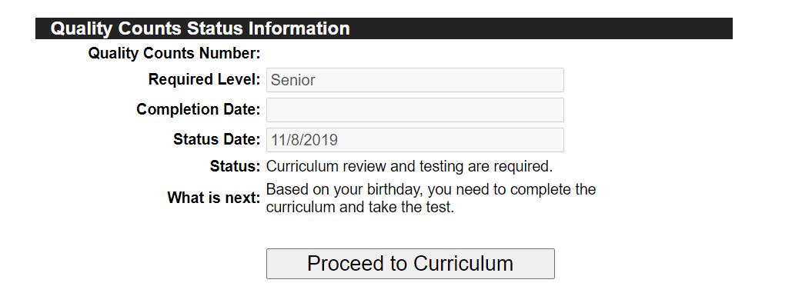
- After you click on Proceed to Curriculum, you will be redirected to a screen that looks like this.

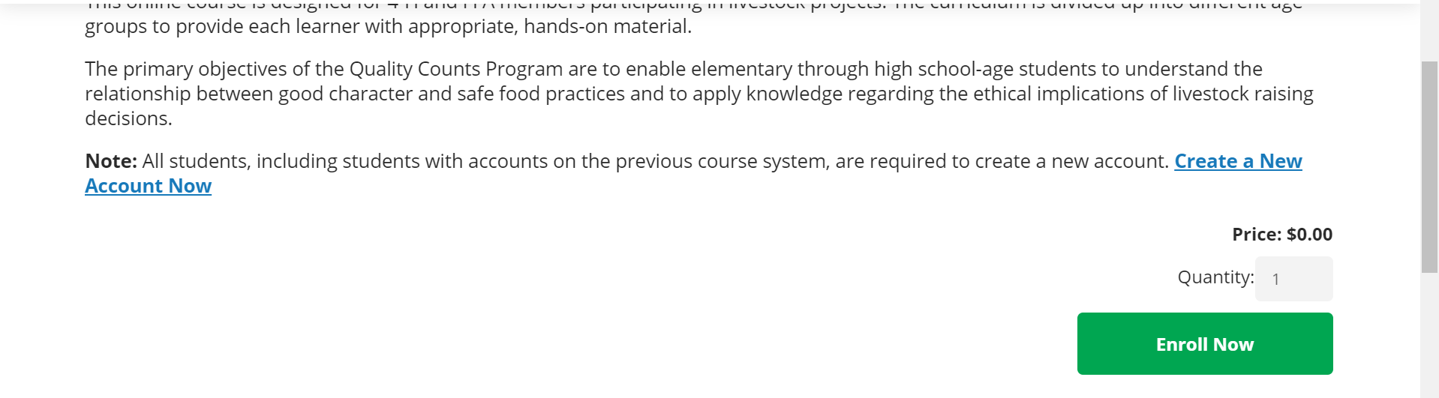
- Scroll to the bottom of the screen until you see this: And click on Enroll Now

- After you click on Enroll Now, you will see the following screen: Click on Sign in, in the top right corner of the screen.
- After clicking on sign in, you will see the following screen. Click on Register in the “Are you a new learner box”
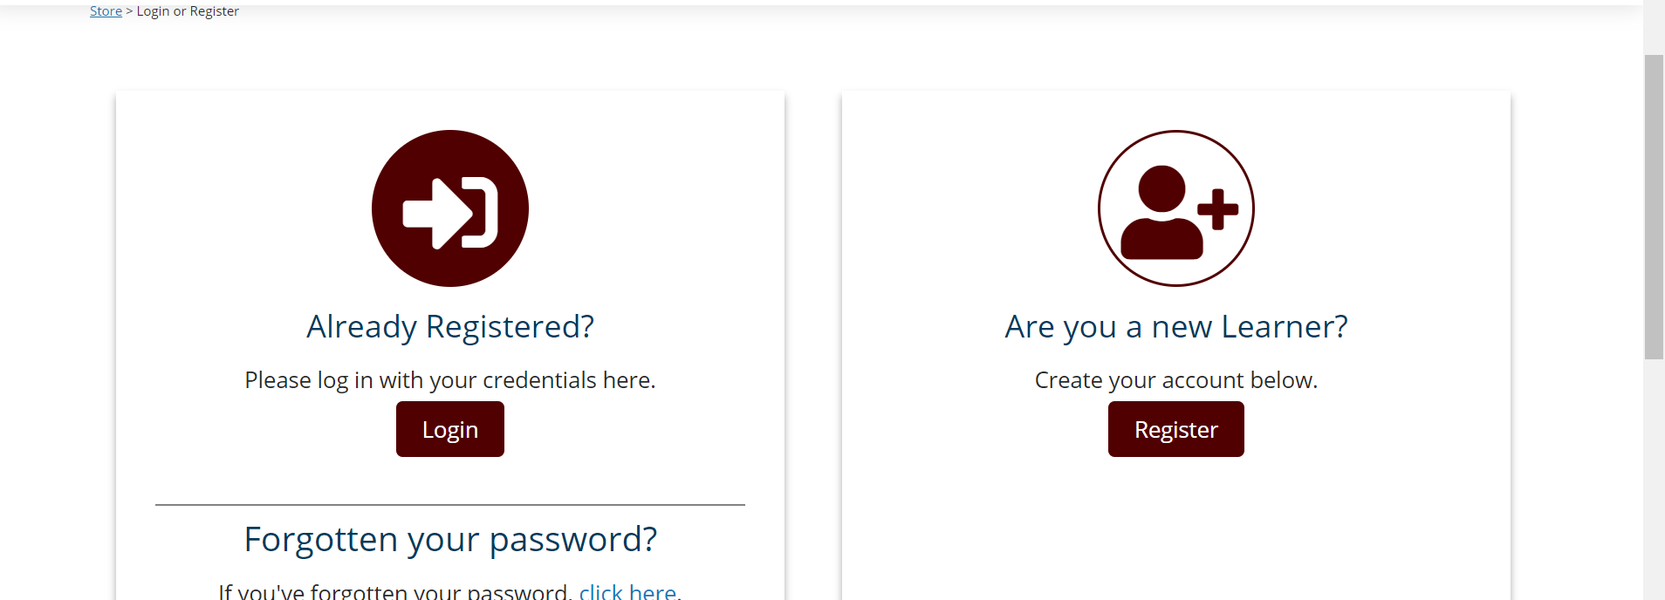

- After you click on Register you will be redirected to a screen that looks like this: You will need to fill out every box that has a red asterisk next to it.
*Helpful Hints
1. Make your username something EASY that you will remember!! Ex: FirstnameLastname (with the first letter of your first and last name capitalized. Ex: JohnDoe
2. Make your password something EASY that you will remember!! Ex: Yourschool1! (with the first letter of your school followed by the #1, and then an exclamation point. Make sure the password is at least 8 characters long as well) Ex: Cywoods1!
3. DO NOT USE YOUR SCHOOL EMAIL ADDRESS
4. YOU DO NOT NEED ANYTHING FOR COMPANY NAME
5. YOU DO NOT NEED ANYTHING FOR PROFESSIONAL LICENSE OR ID NUMBER
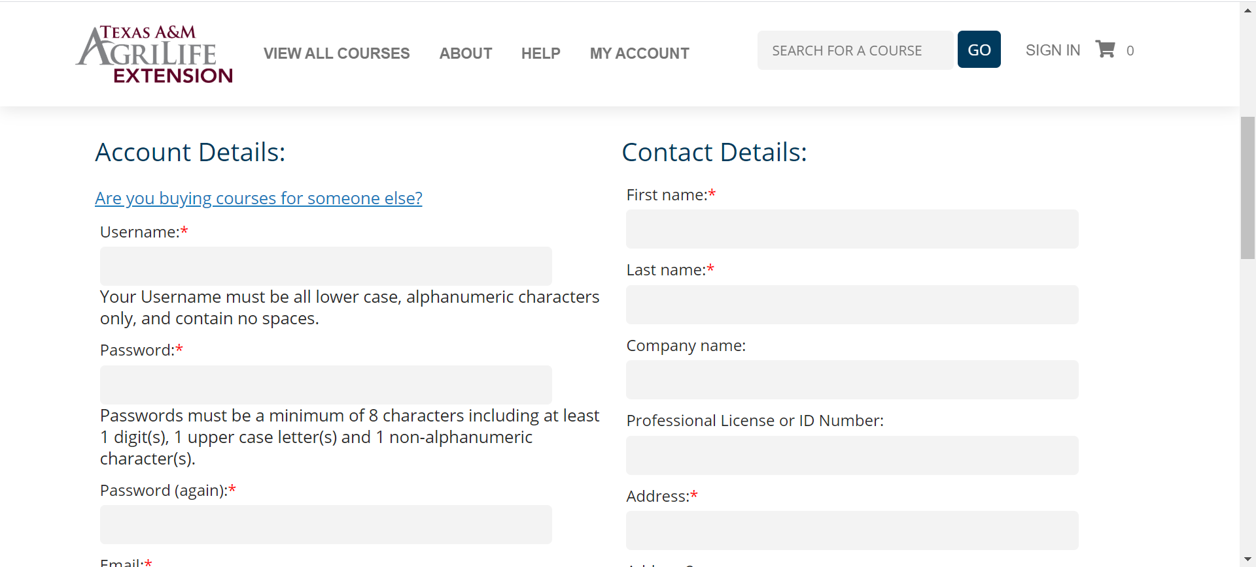
6. YOU LIVE IN HARRIS COUNTY

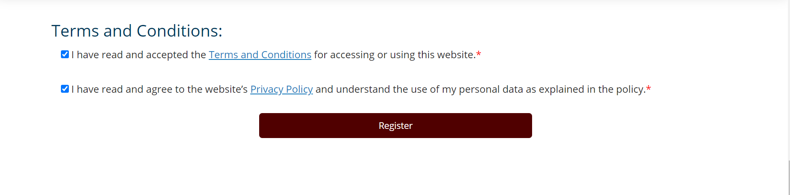
- After you fill out all of the required information, you will need to scroll down and click on the 2 check boxes under Terms and Conditions, and then click on Register
- After clicking on Register, you will be redirected to the following screen. Click on the 4-H and Youth box.

- After you click on 4-H and Youth, you will be redirected to the following screen. Click on the Quality Counts Box

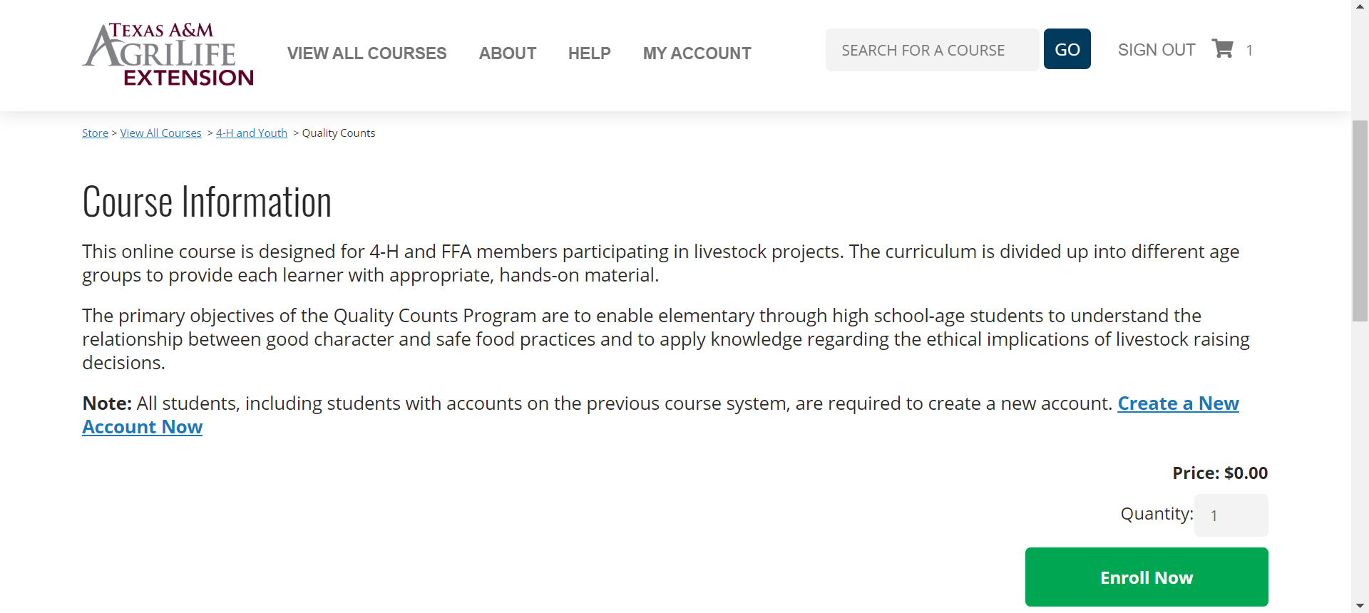
- After you click on Quality Counts, you will be re-directed to the following screen. Click on Enroll Now like you did previously in step 10.

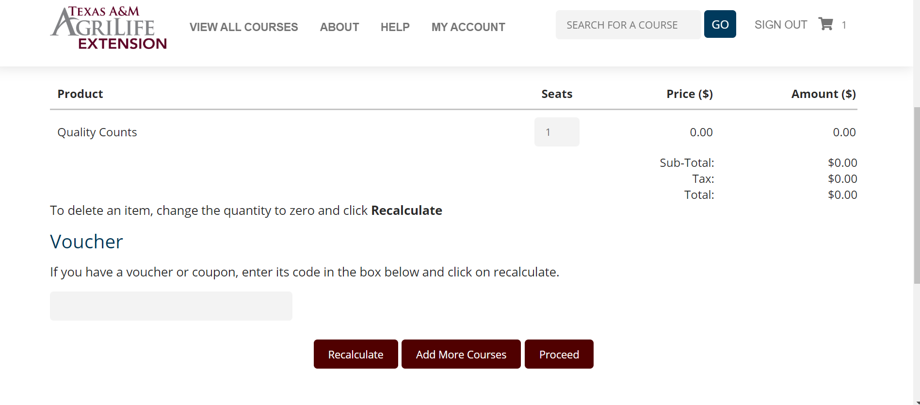
- After you click on Enroll Now, you will be re-directed to the following screen. You will need to click on Proceed
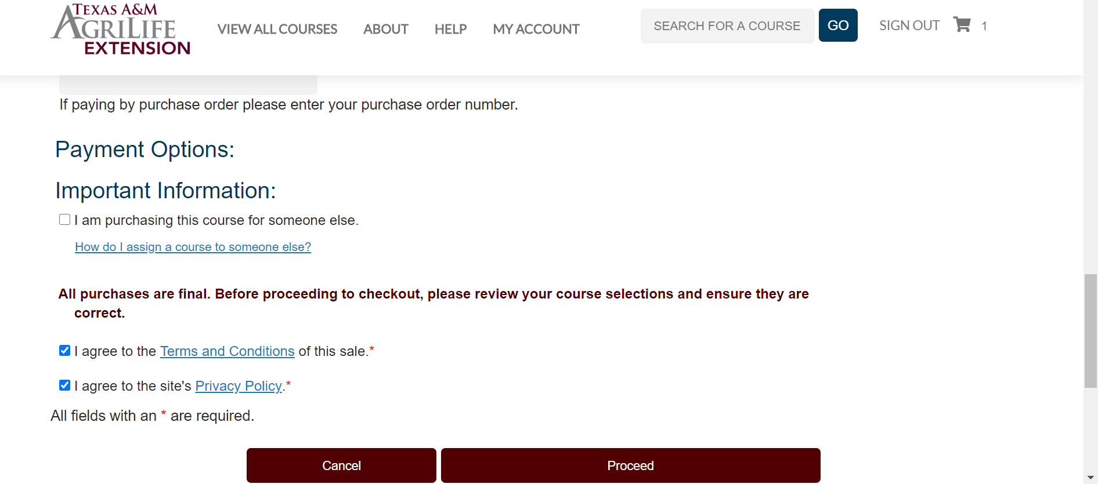
- After you click on Proceed, you will be redirected to this screen. You will need to scroll to the bottom, click the following check boxes, and then click proceed.

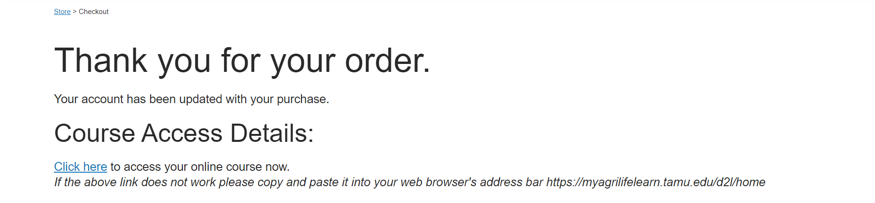
- After clicking on proceed, you will be redirected to the following screen. Click on Click Here
- After clicking on Click Here, you will be redirected to the following screen. Click on the Quality Counts Box.
- After clicking on the Quality Counts Box, you will need to click on Senior: Grades 9-12, and then Introduction to Quality Counts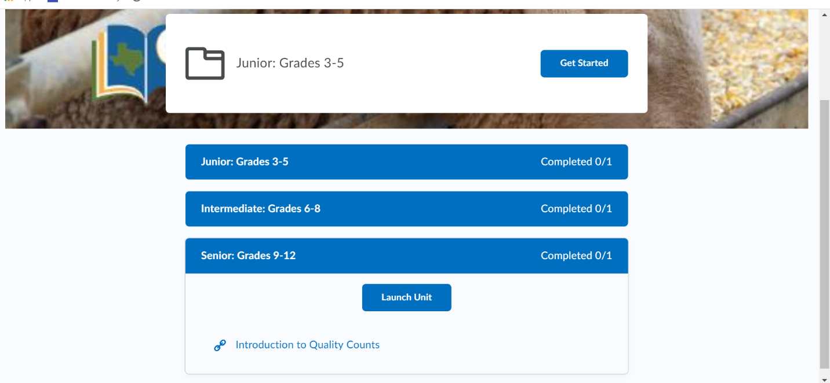

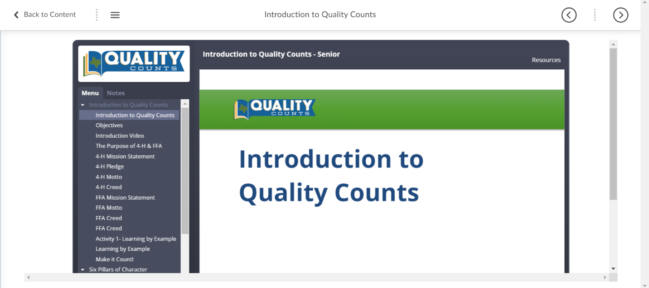
- After clicking the Introduction to Quality Counts, you will be redirected to this screen. Click on the arrows to move between the Quality Counts Course. Some pages have videos that you will have to watch. Watch them carefully because you will need to complete assessments/ quizzes throughout the course. You must pass the assessments to move forward.

- Overall, the course should take you about 2 hours to complete. When you are done, you will be redirected to a screen that gives you a link that says “Proceed to Test.” Click on that. You must score an 80% or better to pass the Quality Counts Exam.

